Manufacturing Execution System

Overview
1. install Java

$ java –version

2. install Maven

$ mvn –version

4. install Tomcat (by default on port 8080)

$ %CATALINA_HOME%\bin\startup.bat

http://localhost:8080

3. install Jenkins (on a port other than 8080 so it doesn’t interfere with Tomcat)

$ java -jar jenkins.war --enable-future-java --httpPort=9090

http://localhost:9090

5. create a top level projects folder

$ mkdir ~/projects

6. in the top level projects folder create a Maven project for the app

$ mvn archetype:generate -DgroupId=<some.url> \
-DartifactId=<somename> \
-DarchetypeArtifactId=maven-archetype-webapp \
-DinteractiveMode=false

This’ll create the basic framework for a Maven project.

C:\projects\somename
src
main
resources # static assets/config files
webapp
WEB-INF
web.xml # servlet/URL mappings
index.jsp # default home page
pom.xml # Maven config

7. the back end/server side uses Java servlets so we need to add this dependency to the pom.xml file

<packaging>war</packaging>
<dependencies>
<!-- Example: Servlet API -->
<dependency>
<groupId>javax.servlet</groupId>
<artifactId>javax.servlet-api</artifactId>
<version>4.0.1</version>
<scope>provided</scope>
</dependency>
</dependencies>

8. configure and test the Maven build

Add the Maven plugin to pom.xml

<build>
<plugins>
<plugin>
<artifactId>maven-war-plugin</artifactId>
<version>3.3.2</version>
<configuration>
<failOnMissingWebXml>false</failOnMissingWebXml>
</configuration>
</plugin>
</plugins>
</build>

Test the build in project root

$ mvn clean package # deletes previous build then compiles, tests, and packages

Maven will package as defined in the pom.xml file...

<packaging>war</packaging>

9. Install Git…

$ git –version

Initialize Git in the project’s root directory…

$ git init

This create a hidden directory ‘.git’ in the project’s root directory.

Create a ‘.gitignore’ file to list those files you don’t want to manage through Git.

Stage and commit the code...

$ git add .
$ git commit -m “Initial commit”

Connect to the remote repository…

$ git remote add origin <url>
$ git push -u origin master

Verify Git

$ git status
10. create a Jenkins pipeline

Jenkins needs some plug-ins installed before we can use it to create a CI/CD pipeline.

Go to settings → system configuration → plug-ins and check if the following are already installed:

- Maven Integration
- Deploy to container

If these are not installed search for them in available plug-ins, select them and install them.

Once these are installed we can create a Jenkins job to automate our pipeline. We can do this using either the Jenkins GUI at localhost:9090 or by creating a Jenkinsfile in our project’s root directory.

A Jenkins file is a DSL (Domain-Specific Language) file written in a Java dialect called Groovy. Here’s a basic example…

pipeline {
agent any
stages {
stage('Build') {
steps {
sh 'mvn clean install' # for Windows substitute ‘sh’ for ‘bat’
}
}
}
}

In Jenkins GUI we need to…

1. create a new pipeline item and give it a name

2. select GitHub project from General options and supply the URL of the repository from step #9

3. configure a trigger for the build i.e. changes to the repository or periodic polling for changes etc

4. under Pipeline choose the definition as Pipeline script from SCM, the SCM source as Git (supplying details), and the script path as Jenkinsfile (the file in the project root).

Maven
Maven has three standard lifecycles sub-divided into phases which are sub-divided into goals.

Lifecycle | Purpose | Key Phases
default | Builds and deploys your project | validate, compile, test, package, verify, install, deploy
clean | Cleans up previous builds | pre-clean, clean, post-clean
site | Generates project documentation | pre-site, site, post-site, site-deploy

Maven has multiple standard phases

Phase | What It Does
validate | Checks if the project is correctly configured
compile | Compiles the source code
test-compile | Compiles test source code
test | Runs unit tests
package | Bundles compiled code into .jar, .war, etc.
verify | Runs integration tests or checks on the packaged code
install | Installs the artifact into your local Maven repo (~/.m2)
deploy | Uploads the artifact to a remote repository (e.g., Nexus, Artifactory)

Phases can be invoked directly…

$ mvn <phase> # running a later phase will run all phases up to/including that phase

Phases have steps called goals. Some common ones include...

Plugin | Goal | Purpose
maven-compiler-plugin | compile | Compiles main source code
maven-compiler-plugin | testCompile | Compiles test source code
maven-surefire-plugin | test | Runs unit tests
maven-jar-plugin | jar | Packages code into a JAR
maven-war-plugin | war | Packages code into a WAR
maven-install-plugin | install | Installs artifact to local repo
maven-deploy-plugin | deploy | Deploys artifact to remote repo
maven-clean-plugin | clean | Deletes target/ directory
maven-resources-plugin | resources | Copies and filters resources
maven-site-plugin | site | Generates project documentation

Goals can be invoked directly…

$ mvn <phase>:<goal> # i.e. mvn compiler:compile

Docker
1. install Docker Desktop
2. Add a stage to the project’s Jenkinsfile to stop any running instance of the Docker container and then deploy the War file into a Docker container running Tomcat.
stage('Deploy to Docker/Tomcat'){
steps {
bat "docker rm -f <instance name>" // stop running instance
bat '''
docker run -d ^
--name tomcat-docker-sandbox ^
-p 8080:8080 ^
-v C:/development/projects/mes/target/mes.war:/usr/local/tomcat/webapps/mes.war ^
tomcat:9.0
'''
}
}

Troubleshooting
If Jenkins reports errors with Docker/Docker Compose make sure Docker Desktop is running!

Useful Docker Commands
Run these commands in the directory that contains the docker-compose.yml file.
$ docker compose up -d # start Docker in detached mode
$ docker compose down -v # stop Docker and delete container

Oracle
To run Oracle within a Docker container using Docker Compose you need to…
1. create a docker-compose.yml file as follows..
services:
oracle:
image: gvenzl/oracle-free:latest
container_name: mes-oracle
environment:
ORACLE_PASSWORD: sunderland
ports:
- "1521:1521"
networks:
- backend
volumes:
- ../oracle/init:/container-entrypoint-startdb.d
networks:
backend:

^ this yml file defines an Oracle instance with a startup script mes/oracle/init/init.sql. NOTE this script only runs when the container is initially created! If you want to run it again you need to delete the container in Docker Desktop!
2. start Docker Desktop and run Docker Compose from the command line to test the YML file before incorporation into Jenkins…
$ docker compose -f docker\\docker-compose.yml up
You can connect to the running database from Docker Desktop via the terminal as the database administrator…

sqlplus system/oracle@localhost:1521/FREE

…and as the application administrator…

sqlplus admin/sunderland@localhost:1521/mes

SQL Developer
You can connect to the database via SQL Developer by defining a connection…
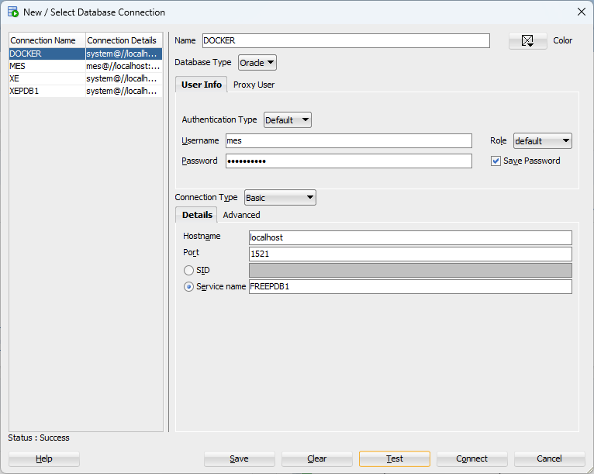

Git

Hosting Locally
To host the repository locally…
- create a local bare repository…
$ mkdir <path>
- initialise the local bare repository
$ cd <path>
$ git init --bare
- remove the link between the local and remote repository…
$ git remote remove origin
- in the project’s root directory push the project to it…
$ git remote add <name> <path>

Committing and Pushing
In the project...
$ git add <filename>
$ git commit -m “comment”
$ git push

Useful Git Commands
$ git remote -v # list all remote repositories
$ git remote remove <name> # break the link between local and <name> remote

Testing

Overview
Under the project root we’ll create these folders for our test scripts.
my-app/
├── pom.xml
├── src/
│ ├── main/java/... # application code
│ └── test/
│ ├── java/... # JUnit server tests
│ └── playwright/ # Playwright client tests
│ └── tests/

Junit
1. add the junit dependency to the project’s pom.xml file

<dependency>
<groupId>org.junit.jupiter</groupId>
<artifactId>junit-jupiter</artifactId>
<version>5.10.0</version>
<scope>test</scope>
</dependency>
2. add a simple JUnit test in src/test/java

@Test
void testServerEndpoint() {
HttpResponse<String> response = Unirest.get("http://localhost:8080/my-app").asString();
assertEquals(200, response.getStatus());
}

Playwright
3. install node.js and Playwright in the project’s root directory

npm init -y
npm install -D @playwright/test
npx playwright install

4. add a simple Playwright test in src/test/playwright/tests/example.spec.ts

import { test, expect } from '@playwright/test';

test('homepage loads', async ({ page }) => {
await page.goto('http://localhost:8080');
await expect(page.locator('h1')).toHaveText('Welcome');
});

5. Add build stages to the Jenkinsfile for the JUnit and Playwright tests.

stage('JUnit Tests') {
steps {
sh 'mvn test'
}
}
stage('Playwright Tests') {
steps {
dir('src/test/playwright') {
sh 'npm install'
sh 'npx playwright test'
}
}
}

Troubleshooting
If the Jenkinsfile driven build fails for no obvious reason then consider building on the command line and deploying the WAR file manually.
$ mvn clean package
$ copy target\mes.war C:\apache-tomcat-9.0.108\webapps
$ npx playwright test
Check the Tomcat terminal session and log files for errors during the deployment of the WAR file that Jenkins might not report.

